6/25
Client groups are not collapsible. The colors of the modules like the financial, tax returns, 1099 are gone. search does not appear properly if you notice the magnifying glass is on top of the search export was not something we need please remove.

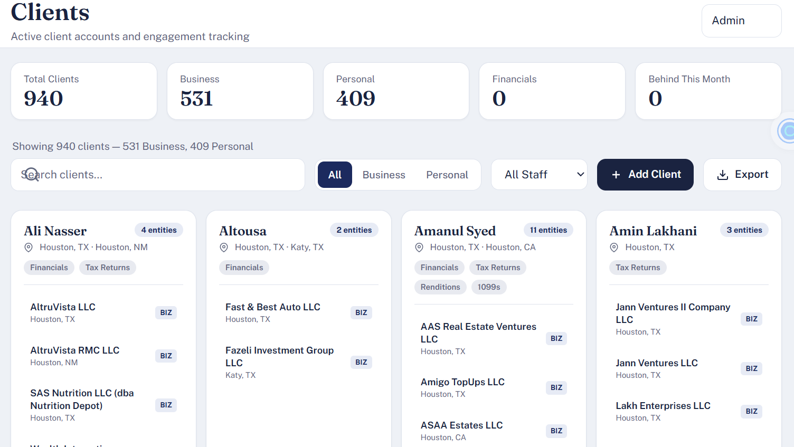

New Client Payroll

Looking at the new client button if you notice payroll I understand where CDG comes from in the payroll details. I looked at the payroll Excel sheet and except for EFTPS password payday processor and who is it assigned to I don't see any CDG anyway, please fix. Under the processor, when you select on others, there is no place to enter other processors.
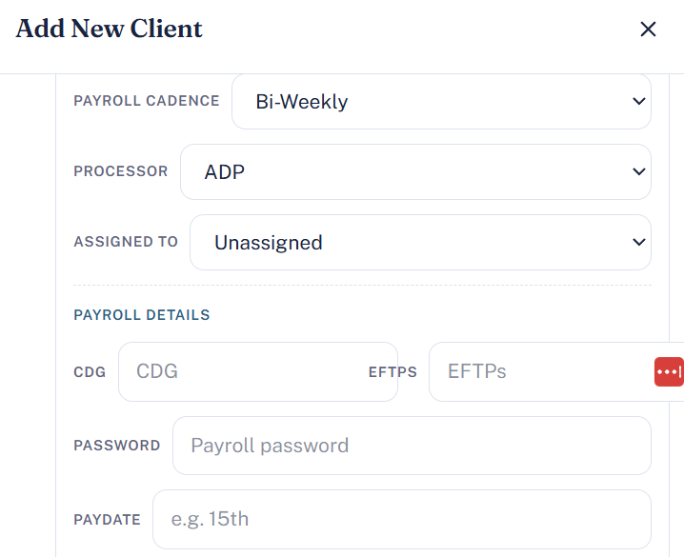

New Client - Sales Tax
Cadence field under sales tax is not editable. Please remove group assignment from the sales tax section. The group will be pulled from client Master data. S/Tax RT should be only labeled as RT. We need the ability to add more sales tax line items as shown in the excel sheet.
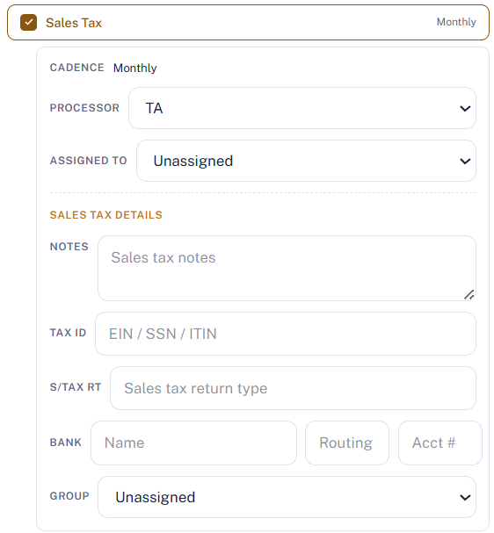

Team Workload

Teamwork load doesn't look anything like the demo I've shared with you please review before you ask me to test again

Financials

Let's start with financial tab we talked about it multiple times that there's a lot of space that is being wasted that you have current here at 2026 and you also have a drop-down in 2026 please text the table is not editable doesn't keep all the months within a table it's scrolling don't like it it's not going to be appreciated please fix here's the screenshot below

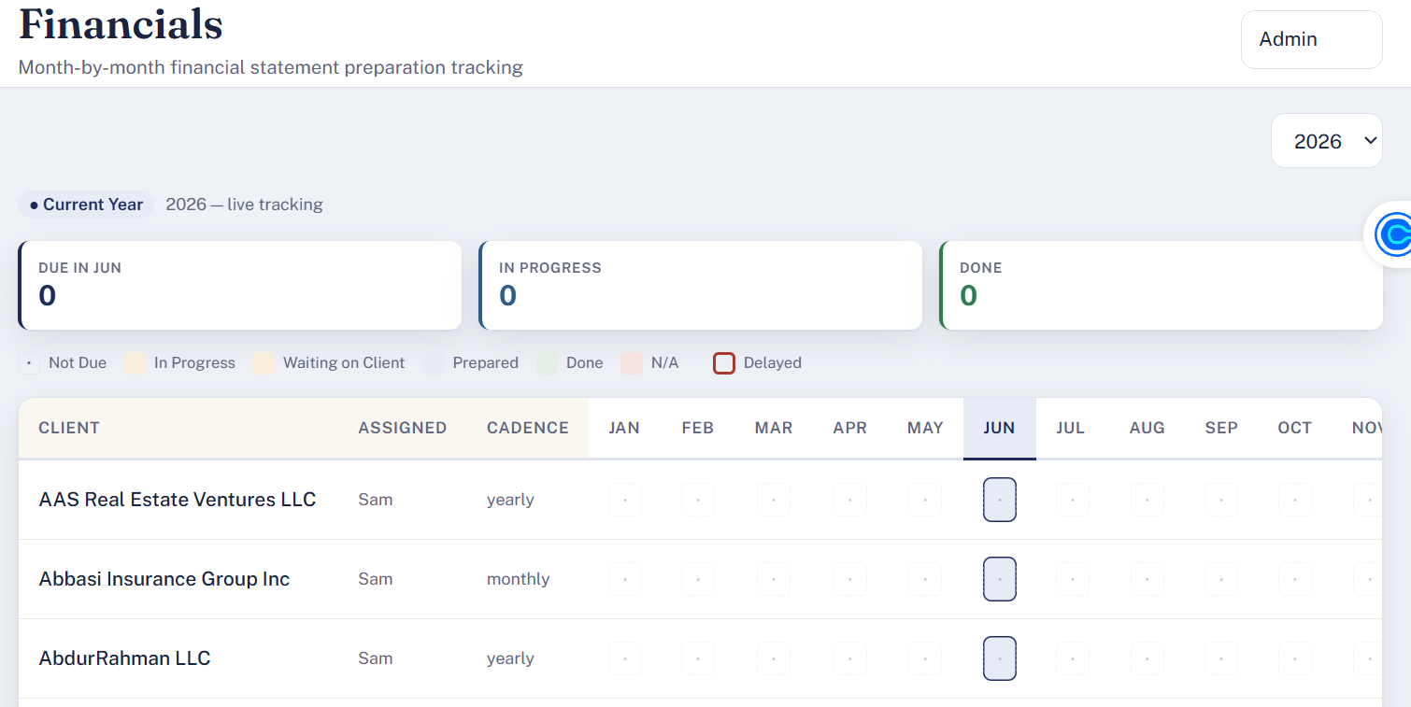

Payroll

I don't see any metrics same issue here current year and the drop-down year show up there's a lot of space that's wasted on the top none of the months for the clients are editable and for payroll I don't see the processor as the field in the table as well I'm not sure what was really improved from our last conversation. Client name is not clickable and then the side panel doesn't open where you can edit and see the entire progress for that client over the year and the services that are selected. Please review the demo in any of the modules under Financial payroll or sales tax when you click on a client a similar panel opens for all modules.

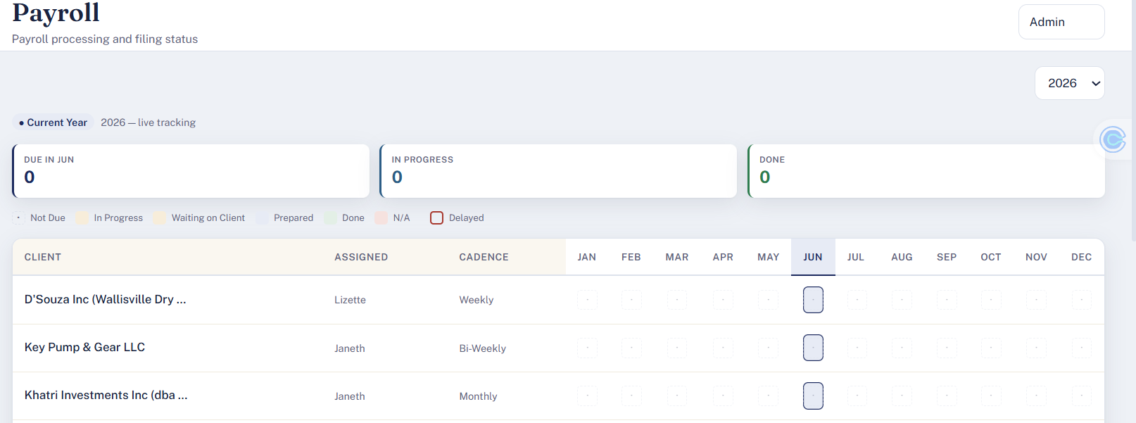
Payroll from the Demo:

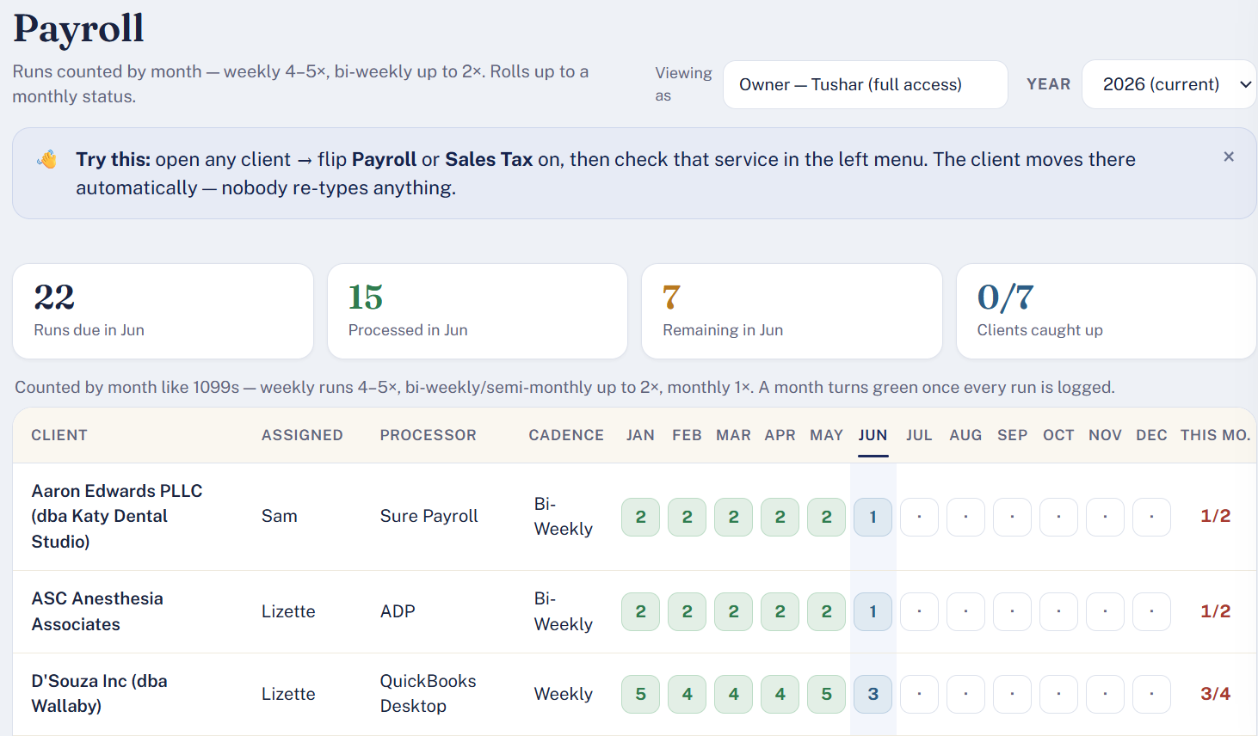

1099’s
Similar challenges with 1099 I don't see any updates made from our last conversation please review the demo I'm attaching a screenshot below from the demo

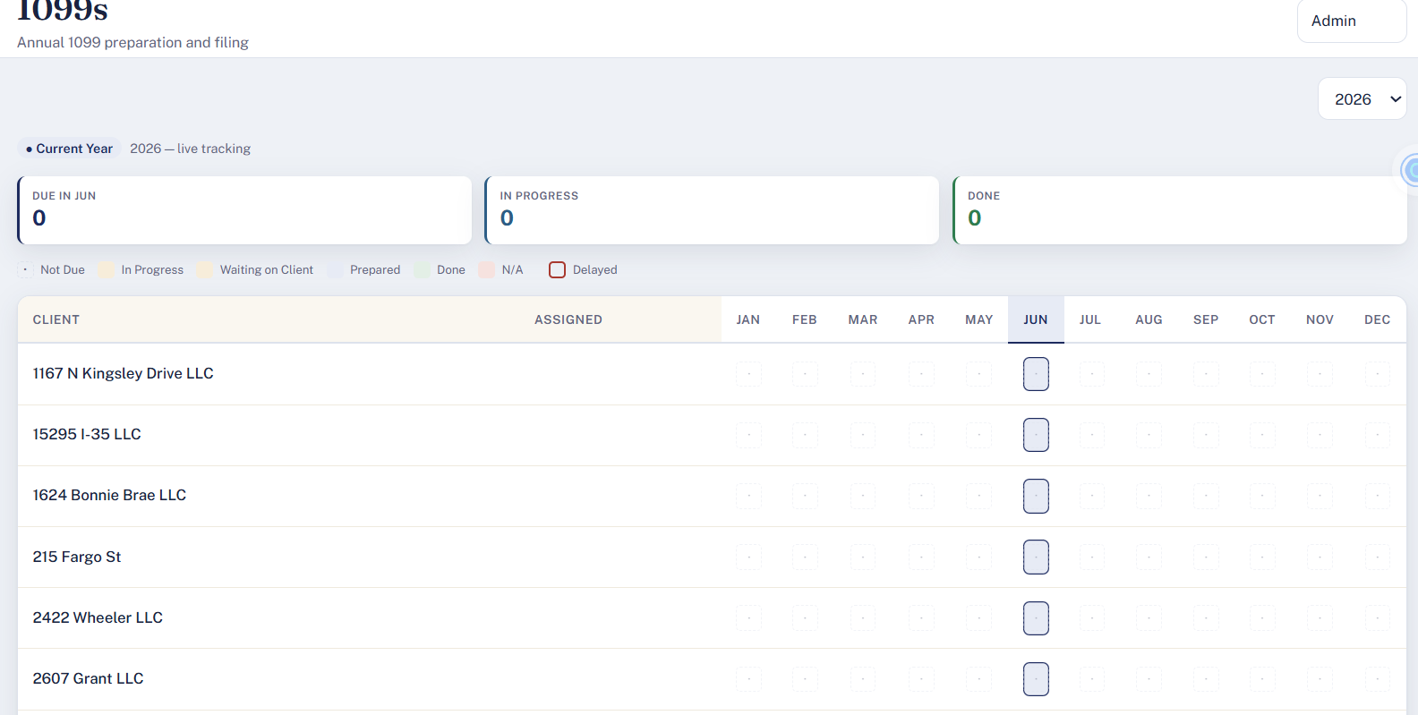
Demo

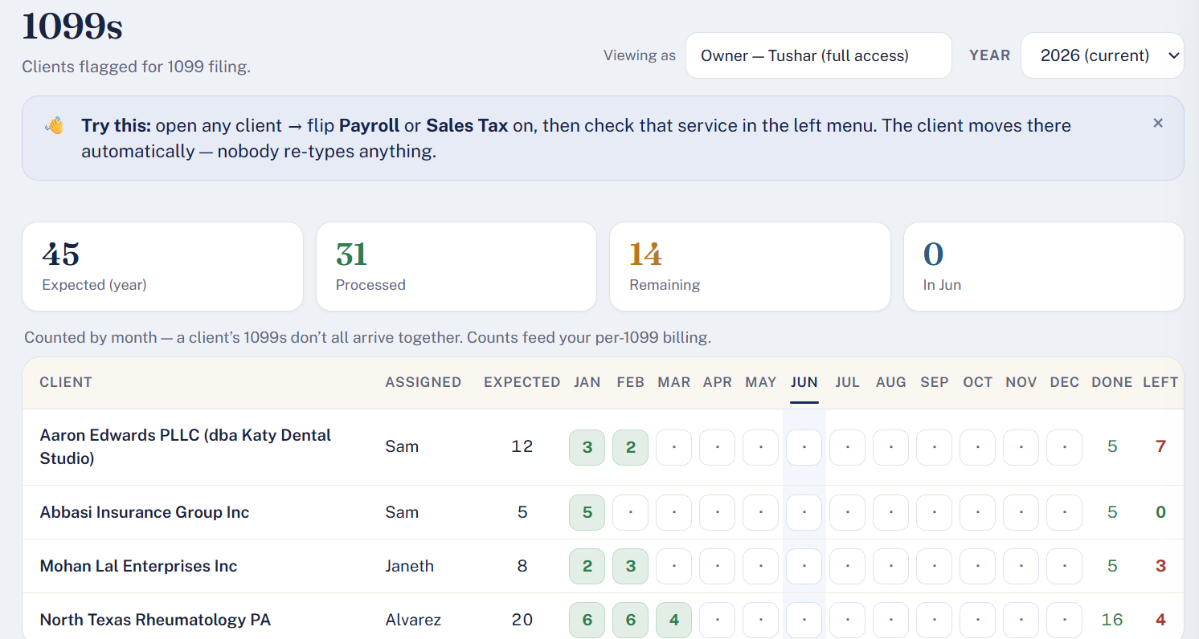

USer & Access

Username is missing from the table need the ability to change the password as well.

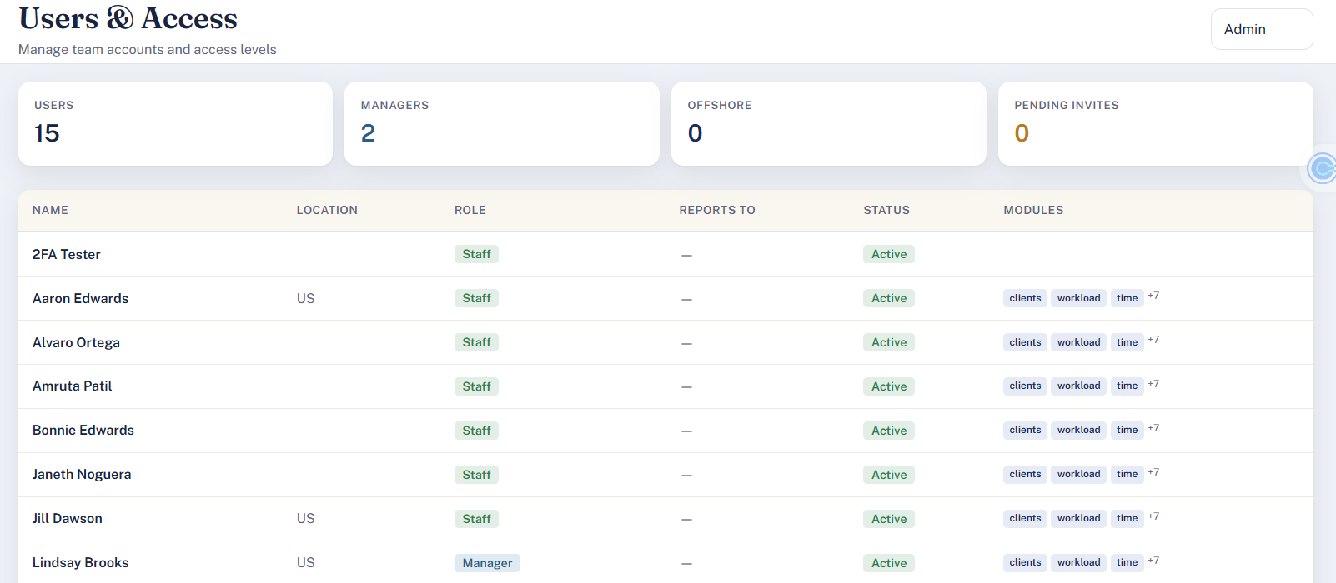

6/27
- We are missing metrics number of clients who are utilizing Financial Services number of clients that are utilizing payroll number of clients that are utilizing sales tax services I see that when I click on personal category all of the personal clients are under unassigned category this doesn't make sense if the group exists then you group them otherwise everyone needs to show as an individual or an independent company.

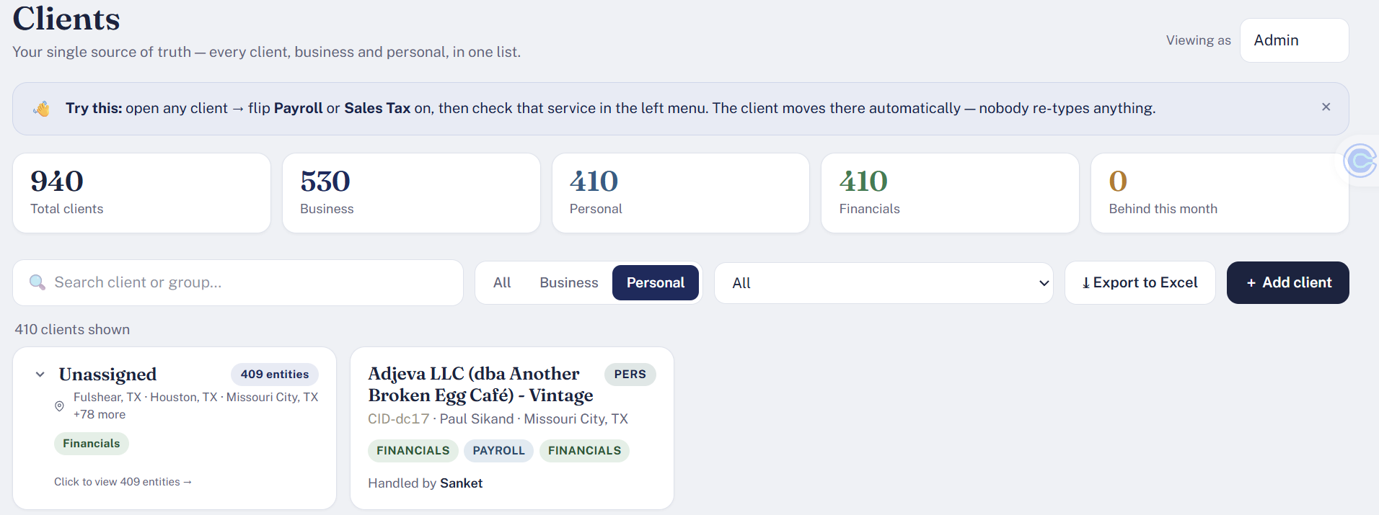

2. In timesheet module we're not able to update the client the client drop down does not populate please fix.

3. Should the following not look like a metric on the top of the screen instead of just showing up as written note?

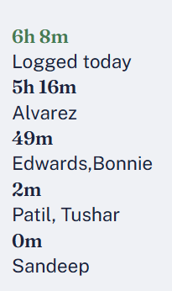

4. I'm not sure what testing did you perform but all the updates for financial, payroll, sales tax for a new client creation, are gone. I am seeing everything from the demo but we had added so many things from the excel sheet all of those don’t exist.

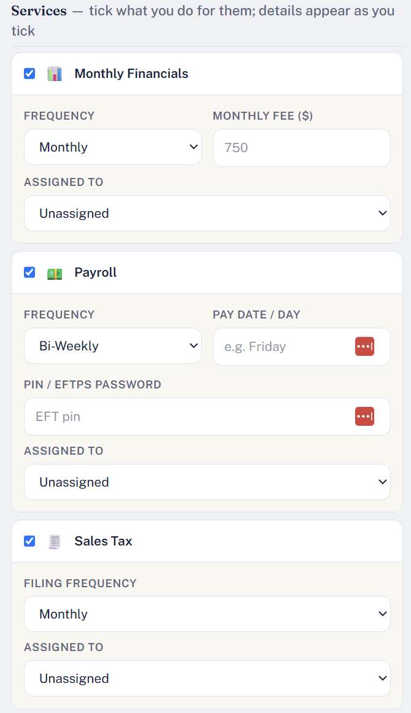
No data uploaded for Sales Tax, payroll, 1099, rendition or Tax Returns. Cannot test anything.

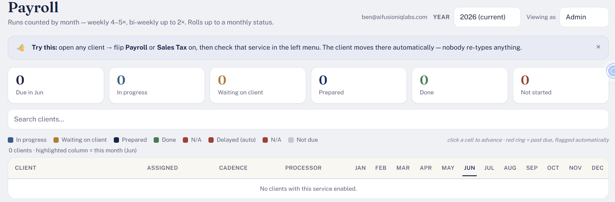

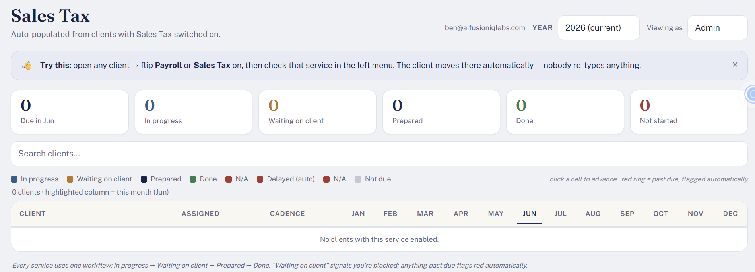

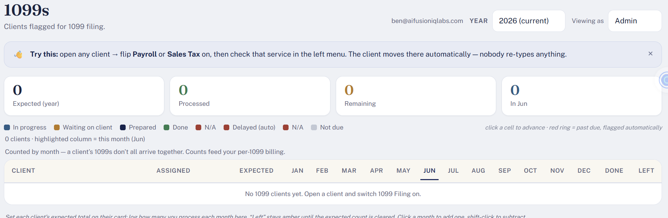

Passwords Page is also missing all the updates as well. Client name, links, purpose things that are in the excel.
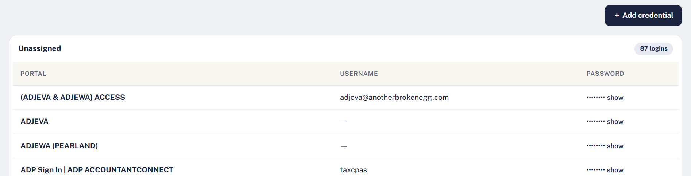

When adding new credentials client drop down is missing all the client names. Username is missing and few other details from the Excel sheet are also missing. I also mentioned that we need a placeholder link for Bank login (tap Bank), that is also missing as well.

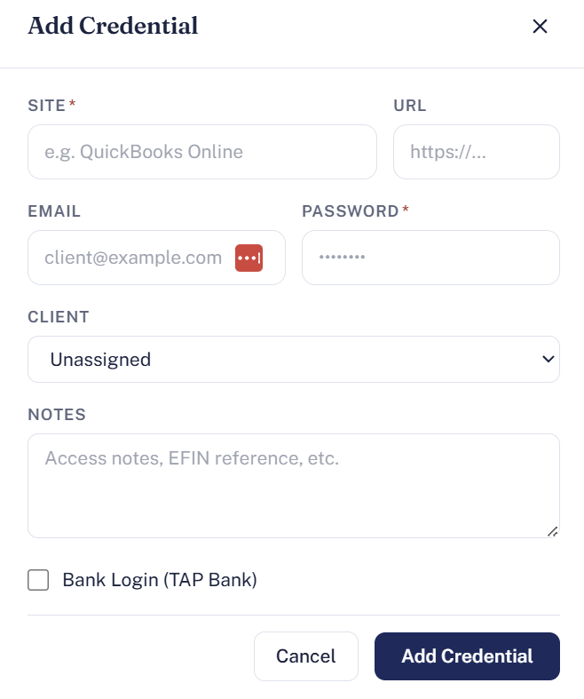

6/29

- In The Matrix section on the Clients module, we do not need “behind this month” metric and “tax return” metric. Tax returns will always be equal to the total number of clients.
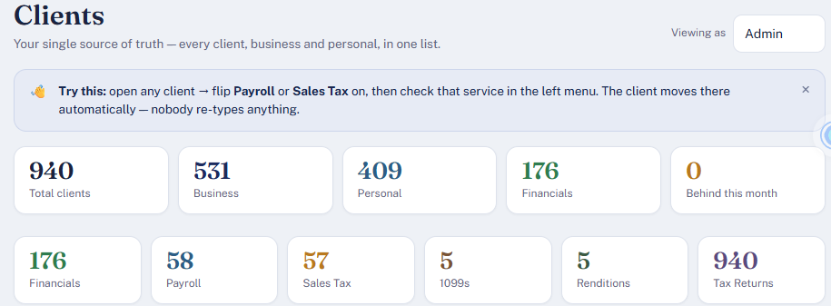

- In the Financial section: monthly fees field is not required this was also mentioned in my previous test that I did on 6/27.

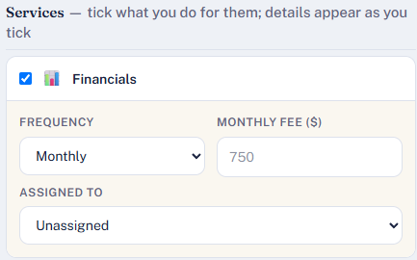

- For payroll pin and EPTPS password are two different fields please do not Club them in one.
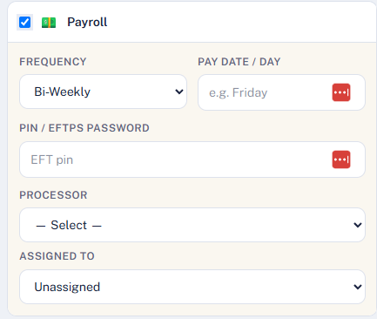
- All the additional fields needed for sales tax Master data are missing. This was also mentioned in my previous test that I did on 6/27. please fix

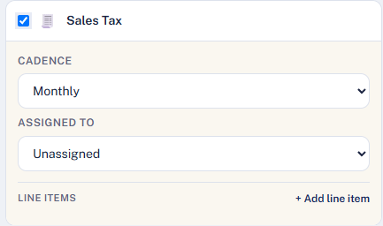

- Tax return type is driven by the client type so return type field is not needed see example below
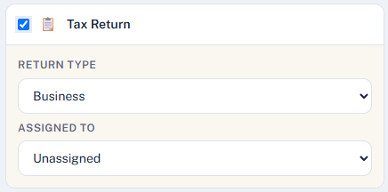

- When you click on edit details for a client, Fields to edit assignee for service do not appear in the edit details page/list.

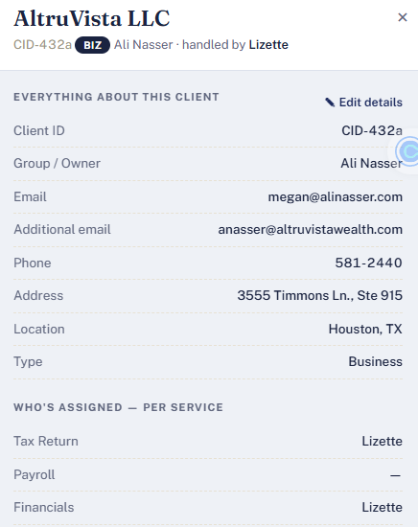

- When a new service is added there is no place to enter all the required fields for that particular service and the screenshot below I clicked on sales tax as a new service for a client I am not able to see the required Fields like tax ID, assignee, password and other required fields. please fix.

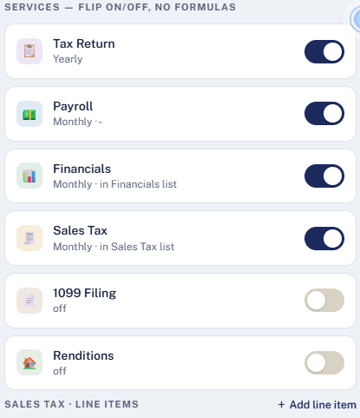

- The screen does not resize to show all months
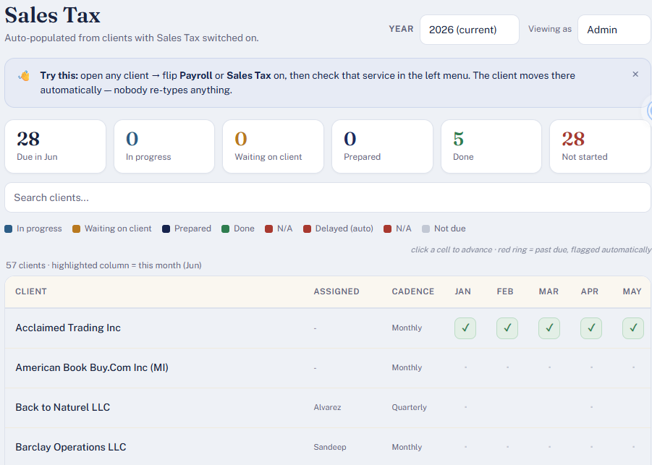

- 1099 page is not loading

- For the payroll module: “total capacity”, utilization and Total payroll runs metric don't make sense. We need to replace them with “Total missing runs”.

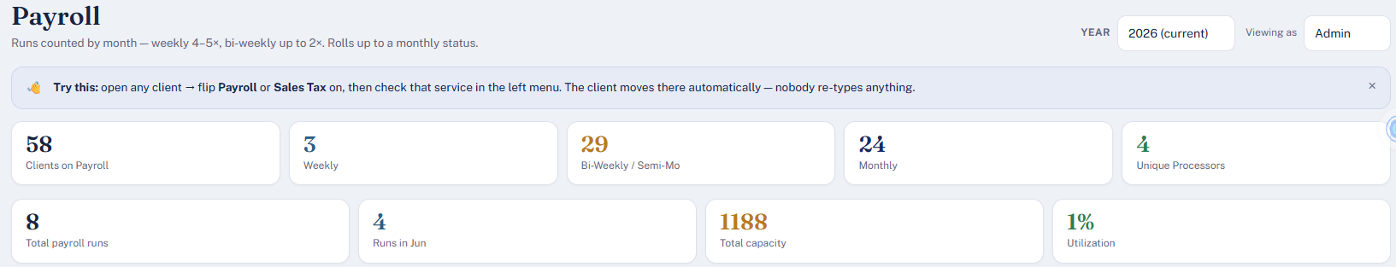

- Assigned and processor data is the same please fix also processor comes first then comes assigned and then Cadence is it possible to allow Changing assigned person from within the screen and filter on Cadence?
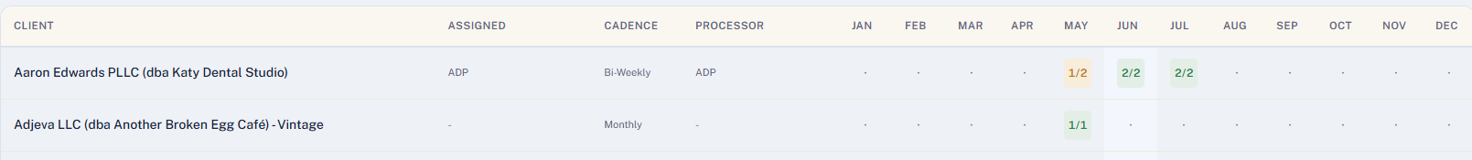

- Can not get to settings page, it redirects to clients page.

- We should not see previous years in the drop-down if you don't have any data for them we only need to retain two years worth of data.


- I cannot click on add user button on the user and access page

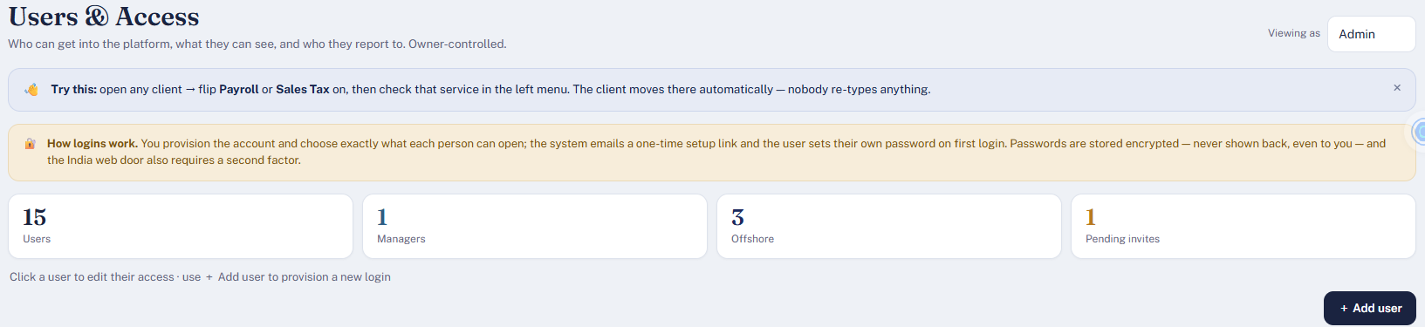

- I need 3 different usernames and passwords to test the experience
- Please share ASAP

7/2
Redesign the Detail page for all modules

Financials Module
Remove - Tax Return, Payroll, sales Tax, 1099 filing, Renditions
Keep Financials - ability to edit all master data fields and need the ability to add comments for each month.(Time of the comment, by who and comment)
Main financial page should show a mark on that month where the comment is added for each client.

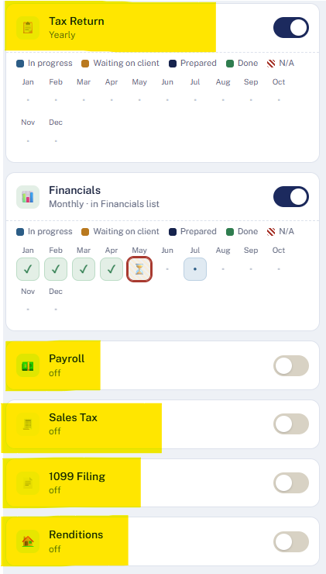

Payroll section
Main page: remove processor, add Bi-weekly Code, PayDay - dropdown day of the week, Pay start date (mm/dd)
- Bi-weekly code 1 - ODD or 2 - EVEN
- Change the ½, 2/2, 1/1 for each month to show the next processing 1/31, 2/13, 2/29. Calculate this date based cadence, Pay start date
Detail page:
- EFTPS Password
- Payroll PIN
- Name and email address (allow multiple)
- Comments by month
Payroll Updates, Columns, and Comment Capture

Tax Return
Need to capture 2 new fields
- Filing state dropdown (all US states to pick from)
- Filing Month dropdown (month of the year to pick from)
In the detailed section:
- Need the ability to capture comments and history of the comments.
- Remove all other modules from the detail page.
Main page:
- hight-light the month then the tax return in due (filing date)
- Add Filing state column and Filing type (C-corp, S-Corp, LLC, Non-profit, Solo)
- Mark the month when comments were recorded
Adding Tax Return Fields and Calendar
Please replace done with Filed (only for tax return)
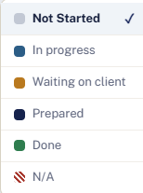

Sales Tax
Detail page: need to change
- add (+add, edit button)
- Replace the client details with sale tax details
- Calendar view should be consistent for all modules, to capture comments and history
Main page: Put a marker on each month where the comment is captured.

7/4

Main page: Display only
Client name
Assigned
Cadence
Pay Day
QBO
For months - all previous months check mark, current month put the processing date

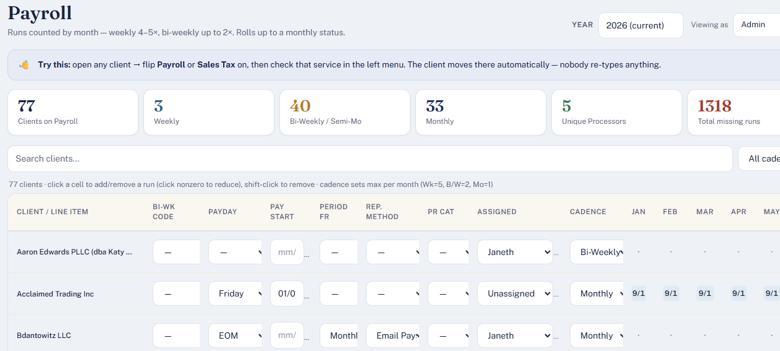

Detail page:
Display only
- Client name
- Email
- Phone number
Edit enabled
- Assigned
- Cadence
- Pay Day
- QBO (Bi-Weekly Code)
- Processor
- EIN
- EFTPS Password
- PIN
- Payroll email (multiple)
- Comments
Fixes:
- You have two sets of comments enabled, please move the one under each month and keep the “notes for payroll” section.
- Remove In progress, waiting on client - the whole line
- Add a dropdown in the notes for payroll section <Month>, Note Type - <Delayed, Waiting on client, Issues, others>, <note text box>

